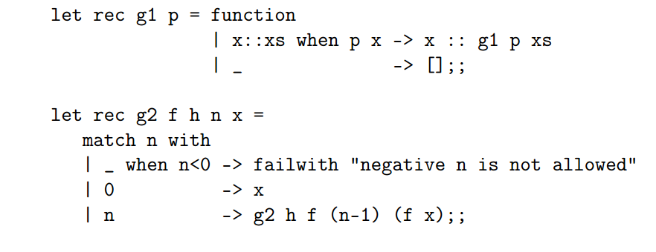

1. G1 is a filter on a list, and filters out all elements in the list for which the predicate p is false.

G2 is a recursive function which applies a function f to an integer x, and does so n times.  
Whenever n is decremented to 0, the resulting x is returned.